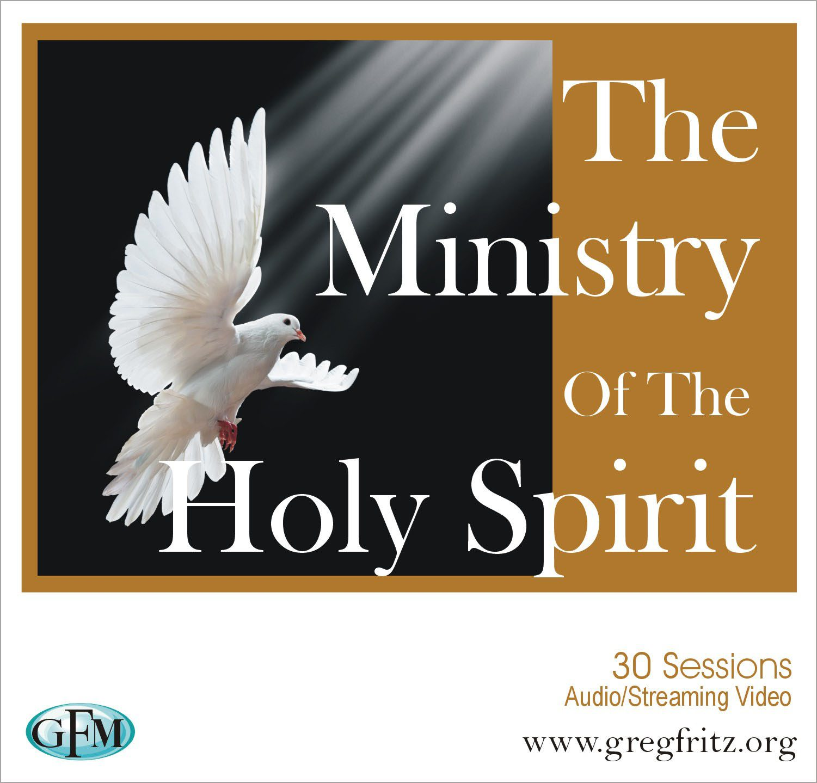

**Joy In the Morning Presents our**

**August-September Discipleship Training Session**

**On**

**The Functions of He Holy Spirit**

**Functions of He Holy Spirit**

He-Holy Spirit is the omnipotent, omnipresent, omniscient, miraculous, supernatural mind of God as He expresses Himself in the various ways as outlined in the hearts of yield vessels. He is the third person of the Godhead, the Holy Trinity- Father, Son, and Holy Spirit. He is not an object or a force of nature. He is never ever to be referred to as an it! He is indeed God manifested in Spirit and is available as a helper and Spirit of Truth, who dwells within believers, guiding them in their walk with God as Kingdom Citizens. It is our goal in the study of these scriptures that you will be able to understand, embrace, and operate in the Holy Spirit’s function as you “Go therefore and make disciples of all nations….” Matthew 28:19-20. Please feel free to continue to utilize the SOAP method for the study and presentation of the scriptures.

1. He leads and directs

**Scriptures:** Mark 1:12; Matt.4:1, Luke 2:27; Luke 4:1, Romans 8:14; Acts 8:29

1. He speaks -in, to, and through.

**Scriptures:** Matthew 10:19-20, Acts 1:15-16; 2:1-4, 13:2, 28:25-27, Hebrews 3:7-11

1. He gives the power to cast out devils

**Scriptures:** Matthew 12:25-28

1. He Holy Spirit releases power

**Scripture(s)**: Luke 4:14

1. He anoints

**Scriptures:** Luke 4:18-19, Acts 10:36-38

1. He gives new birth

**Scriptures:** John 3:5,8

1. He ministers Truth

**Scriptures:** (John14:17, 15:26, 16:13)

8. He dwells in people

**Scriptures:** John14:14, Romans 8:9,11, 1 Corinthians 3:16

9. He proceeds from the Father

**Scriptures:** John 15:26

10. He shows us things to come

**Scriptures:** John 16:13)

11. He brings direction and guidance

**Scriptures:** Mark 13:36, 13:11, Acts 10:19, 11:12, 21:11; 1 Timothy 4:1

12. He produces fruit in our lives

**Scriptures:** Galatians 5:22-23, Ephesians 5:9

13. He Holy Spirit provides power for signs, wonders, and preachings

**Scriptures**: Acts 1:8, 1 Corinthians 2:4

14. He brings revelation

**Scriptures:** Luke 2:25, 1 Corinthians 2:10, 12, Ephesians 1:17-19, 3:5

15. He washes, sanctifies, purifies, and justifies.

**Scriptures:** Romans 15:16, 1 Corinthians 6:11, 2 Thessalonians 2:13, 1Timothy 3:16, 1 Peter 1:2, 22

16. He has the power of conception and anointing for God’s purposes

**Scriptures:** Matthew 1:18-20, Luke 1:35

17. He teaches

**Scriptures:** Luke 12:12, John 14:26, 1 Corinthians 2:13, 1 John 2:27

18. He appoints ministries and gives them authority

**Scriptures:** Acts 20:28

19. He releases love

**Scriptures:** Romans 5:5

20. He is righteousness, peace, and joy

**Scriptures:** Romans 14:17, 15:13, 1 Thessalonians 1:6

21. He confesses Christ’s Lordship

**Scriptures:** 1 Corinthians 12:3

22. He provides keeping power

**Scriptures:** 2 Timothy 1:14

23. He brings renewal

**Scriptures:** Titus 3:5

24. He convicts the world

**Scriptures:** John16:8

25. He speaks to the churches

**Scriptures:** Revelations 2:11, 17, 29, 3:6,13,22

26. He strengthens us with might

**Scriptures:** Ephesians 3:16

27. He gives access to the Father

**Scripture:** Ephesians 2:18

28. He changes us into the image of Christ

**Scripture:** 2 Corinthians 3:17

29. He seals us

**Scriptures:** 2 Corinthians 1:22, Ephesians 4:30

30. He gives gifts

**Scriptures:** 1 Corinthians 12:4-11, Hebrews 2:4

31. He leads into worship

**Scriptures:** John 4:23

32. He flows like a river from the spirit man

**Scriptures:** John 7:38-39

33. He gives comfort, health, and strength

**Scriptures:** John 15:26, Acts 9:31

34. He is the spirit of life and gives life

**Scriptures:** Romans 8:1, 10

35. He invites us to walk with Him

**Scriptures:** Romans 8:4-5

36. He helps us in our weakness

**Scriptures:** Romans 8:26

37. He is the Spirit of Adoption

**Scriptures:** Romans 8:15

38. He reveals to us what is given by God

**Scriptures:** 1 Corinthians 2:12

39. He can be grieved

**Scriptures:** Isaiah 63:10, Ephesians 4:30